Team Mario 🍄⭐
The central aim of this project is to investigate how agents with a limited lifespan navigate the trade-off between exploration and exploitation in a spatially structured environment. Our interest lies in understanding how internal states like energy and age influence the agents’ willingness to leave familiar territory in search of food or mates, and how these decisions affect their chances of survival and reproduction. We explore this through two core research questions:
How do agents that start in spatially segregated nests behave when forced to leave in order to survive and reproduce?
The focus is on building and analysing a clean, minimal baseline version of the system that already lays the groundwork for our full exploration/exploitation model, without yet involving sexual reproduction, energy modulation, or behavioural states.
Agents must leave their initial positions, move through the environment, interact, and either reproduce or die. This phase already allows for meaningful questions and comparisons, while remaining conceptually and computationally simple.
The baseline scenario still begins with spatial structure. Agents are spawned in four distinct nests, one for each group: male rabbits, female rabbits, male foxes, and female foxes sex is not yet used! All agents of the same species behave identically and reproduce asexually. The nest structure is retained not for protection, but to seed spatial separation and allow us to study how initial layout affects survival and interaction rates. There is no nesting logic or nest re-entry at this stage.
Baseline setup:
- The environment is a discrete 2D grid with boundaries.
- Four static nest locations are defined at the grid corners.
- Each nest spawns agents of one of the four subgroups.
- All agents have a fixed maximum which decreases by 1 per tick.
- There is no energy mechanic.
- Foxes attempt to eat rabbits when they occupy the same cell. Wating is probabilistic but frequent enough to sustain predator survival.
- When a fox eats a rabbit, it immediately reproduces asexually (spawning another fox).
- Rabbits reproduce independently at a fixed probability per tick, as long as they are alive.
- Movement is governed by simple random walk logic. No directionality, no velocity variation.

In this minimal version, agents are not yet adapting behaviour based on internal state. They don’t move faster when their lifespan is nearly depleted, and they do not selectively seek food or partners.
The intention is to keep the simulation completely deterministic at the rules level and observe what kind of interaction patterns emerge purely from spatial distribution and reproduction/eating cycles
To evaluate this baseline, we simulate the system across multiple random seeds and collect basic metrics: population count of foxes and rabbits at each tick, number of reproduction events, and timing of extinction if it occurs. These values are averaged across at least 20 simulation runs and visualised using line plots with 95% confidence intervals

In week 2, we extend the baseline model to incorporate internal state variables and structured interaction logic, turning our previously neutral agents into behaviourally dynamic individuals.
How does linking agent behaviour to internal lifespan and energy states influence the balance between exploration and exploitation in survival and reproduction?
The focus shifts from simple collision-driven interaction to conditional, state-based decisions that allow agents to adjust behaviour over time.
The most important conceptual shift introduced this week is to treat lifespan not just as a passive timer, but as the core internal variable that drives behavioural urgency. Lifespan continues to represent a hard biological limit: each agent ages one unit per tick and dies once their maximum lifespan is reached. However, rather than introducing a second variable like energy, we embed urgency directly into the agent’s behaviour by linking their movement speed to remaining lifespan. As agents get closer to death, they become increasingly desperate and begin to explore more actively in search of food or mates.

The dynamics are defined as follows:
- Agents lose 1 lifespan unit per tick, regardless of movement.
- If lifespan reaches 0, the agent dies.
- Movement speed increases as lifespan decreases:
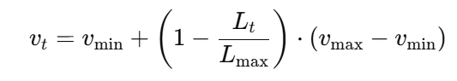

This formulation causes:
- High remaining lifespan → low speed (agents stay local and conserve effort)
- Low remaining lifespan → high speed (agents fan out to explore before death)

When an agent successfully eats (e.g., a fox eats a rabbit), they regain some portion of life, delaying death:
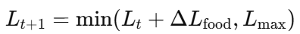

Sexual reproduction is also introduced in this phase. Instead of reproducing asexually after feeding (as in week 1), agents now require the presence of a same-species partner of the opposite sex in the same cell to reproduce.
The probability of reproduction upon contact is configurable, allowing us to explore how selective mating thresholds affect population growth. Importantly, this adds a second layer to the exploration dynamic: not only must agents find food to survive, but they must also find mates to reproduce.
In this way, we create tension between survival-driven movement and reproduction-driven movement, both of which interact with energy and lifespan. In our model, the reproduction probability is linked to the agent’s remaining lifespan: the closer an agent is to dying, the more likely it is to reproduce upon meeting a suitable partner.
This approach captures a naturalistic urgency-to-reproduce dynamic without requiring agents to plan or seek out mates directly. Instead, exploration emerges as a side effect of diminishing lifespan, which increases both movement speed and mating likelihood. In this way, reproduction becomes an opportunistic, internally-driven event.
Nests and core idea of week 2
Each group of agents, male and female foxes and rabbits, starts in its own nest in different parts of the map. These nests are safe zones at the beginning because predators can’t enter. But they don’t contain food, and since agents start separated by sex, they also can’t reproduce if they just stay inside.
Agents lose lifespan every tick, even if they don’t move. As their lifespan goes down, they automatically start moving faster. This pushes them out of the nest naturally, they don’t get told to leave, but if they stay, they eventually die without ever eating or reproducing.
Once they leave, they can find food and mating partners, but they’re also exposed to danger. So, agents face a trade-off between staying safe and actually surviving. If they explore, they might find what they need. If they stay, they avoid predators for a while, but their time runs out.

Into the mechanisms...
How agents decide to move based on life and what’s around them?

To make agents behave more realistically without planning or learning, we introduce a local perception mechanism that allows them to respond to the immediate environment.
Each agent can scan its surroundings within a fixed radius to evaluate whether there are potential opportunities for survival or reproduction. This includes detecting prey (for foxes) or potential mates (rabbits). The agent uses this local information, along with its internal lifespan, to adjust its movement behaviour. The more urgent the situation, either because it is close to death or because there are no opportunities nearby the more likely the agent is to increase its speed and explore further.
We define a unified urgency function UUU, which represents how strong the pressure is for the agent to move. This function is based on a combination of internal state and local opportunity:
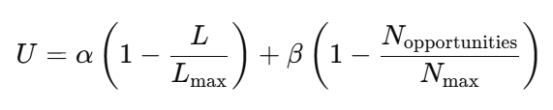

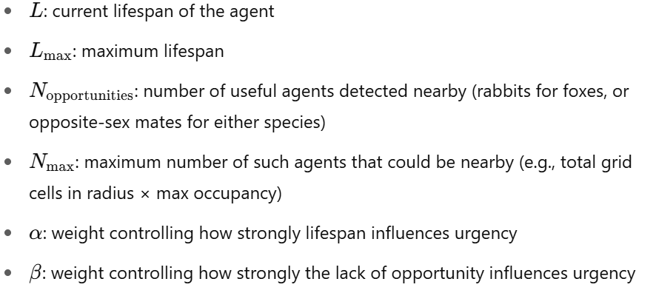

This urgency is then used to scale the movement speed of the agent:
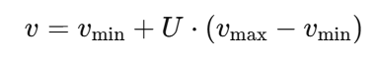

Map Design:
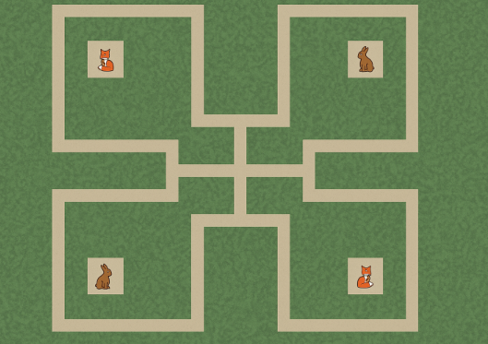
If the map is completely open, agents will meet too quickly and randomly, which makes exploration pointless. Instead, creating a map with soft barriers, like dividing it into four zones with a nest in each corner and connecting them through corridors, slows down movement and forces agents to explore.
We can make a central open area where most encounters happen, while keeping the nests as safe zones. This setup lets you control how fast agents meet and let use investigate our RQ more effectively.
- Out map should not have the barriers in the middle.
Additional optional tests: - Returning to the nest after mating (Rabbits)
Rabbits return to their nest after mating to reflect a natural prey behaviour, going back to safety after taking a risk. Even though the assignment says agents shouldn't have full memory or map knowledge, it's reasonable and allowed for each agent to store the coordinates of the nest it was born in. This isn’t learning or planning, it’s just part of the agent’s internal state, like its sex or lifespan.
After a rabbit mates, it switches to a "return-to-nest" mode. While in this state, its movement becomes biased toward its nest. This doesn’t involve pathfinding.
The rabbit just slightly favours directions that bring it closer to the stored nest position. It doesn’t remember past steps or know where anything else is. Once it reaches the nest area or spends a few steps trying to return, it goes back to normal movement.

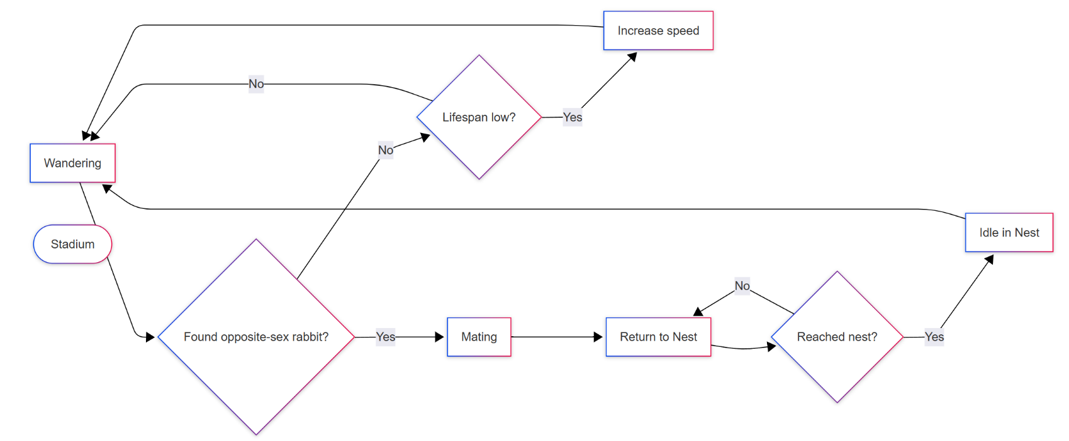
Rabbits life cycle

Hypotheses for Baseline Model (Suggestions)
- Spatial segregation reduces early contact between foxes and rabbits, delaying predation.
Since agents start in separate nests, it will take time before predators and prey meet. This may lead to an initial phase where both populations grow before predation begins to regulate them.
- Asexual reproduction allows rapid rabbit population growth in the absence of early predation.
If foxes don’t leave their nests quickly enough, rabbit numbers will rise exponentially due to automatic reproduction.
- Random movement without urgency leads to high variability in survival outcomes across runs.
Without any state-based behaviour, some runs may result in rapid extinction due to unlucky placement, while others may survive longer just by chance.
Hypothesis for Week 2 (Extended Model)
- The structured map slows down agent interaction, increasing time to first reproduction and predation.
With corridors and corner nests, agents will take longer to reach one another, which delays the first encounters and may shift the population dynamics compared to an open map.
- Foxes have an higher reproductive success than rabbits due to getting more lifespan from predation.
Since foxes can recover lifespan by eating rabbits, while rabbits do not regenerate lifespan, foxes may have more time to find mates and reproduce, leading to an unexpected advantage despite being predators.
- Agents near their own-sex nestmates will have lower reproduction rates due to limited movement.
If an agent remains near a nest that contains only same-sex individuals, it may fail to explore in time, missing its chance to reproduce. This could lead to underpopulation not from predation, but from lack of mate encounters.

